1st Assignment

Cory Hyde

September 12, 2018

# Another Header

## R Markdown

### Some header

This is an R Markdown document. Markdown is a simple formatting syntax for authoring HTML, PDF, and MS Word documents. For more details on using R Markdown see <http://rmarkdown.rstudio.com>.

When you click the **Knit** button a document will be generated that includes both content as well as the output of any embedded R code chunks within the document. You can embed an R code chunk like this:

titanic = read.csv("titanic.csv")  
head(titanic)

## PassengerId Survived Pclass  
## 1 1 0 3  
## 2 2 1 1  
## 3 3 1 3  
## 4 4 1 1  
## 5 5 0 3  
## 6 6 0 3  
## Name Sex Age SibSp  
## 1 Braund, Mr. Owen Harris male 22 1  
## 2 Cumings, Mrs. John Bradley (Florence Briggs Thayer) female 38 1  
## 3 Heikkinen, Miss. Laina female 26 0  
## 4 Futrelle, Mrs. Jacques Heath (Lily May Peel) female 35 1  
## 5 Allen, Mr. William Henry male 35 0  
## 6 Moran, Mr. James male NA 0  
## Parch Ticket Fare Cabin Embarked  
## 1 0 A/5 21171 7.2500 S  
## 2 0 PC 17599 71.2833 C85 C  
## 3 0 STON/O2. 3101282 7.9250 S  
## 4 0 113803 53.1000 C123 S  
## 5 0 373450 8.0500 S  
## 6 0 330877 8.4583 Q

## Including Plots

You can also embed plots, for example:

1)

ggplot(titanic) + geom_point(mapping = aes(x= Pclass, y= Age, color= Fare))

## Warning: Removed 177 rows containing missing values (geom_point).

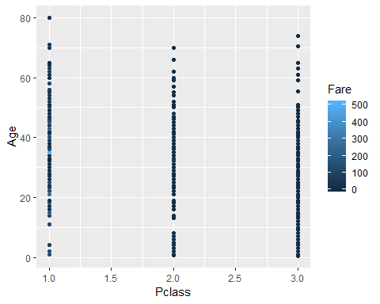

X = Pclass, Y = Age

2) ggplot(titantic)+ geom_plot(Age, Fare, main=Sex, xlab="Age", ylab="Fare")

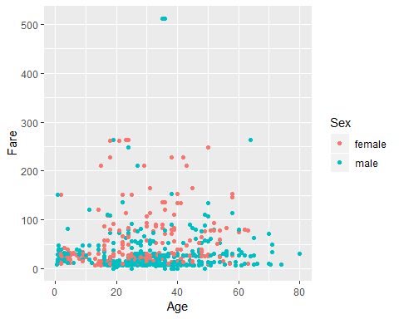

X = Age, Y = Fare

3)   
ggplot(titanic) + geom_bar(mapping = aes(x= Pclass, fill= Sex), position="dodge")

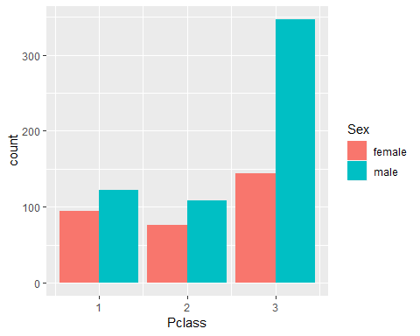

X = Pclass, Y = Age

4) ggplot(titantic)+ geom_plot(Age,Fare,main=Survived,xlab="Age", ylab="Fare")

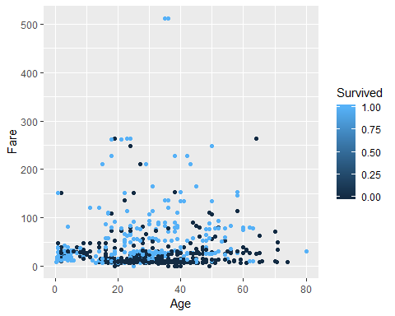  
X = Age, Y = Fare

5)

ggplot(titanic) + geom_point(mapping = aes(x= Sex, y= Age, color= Survived))

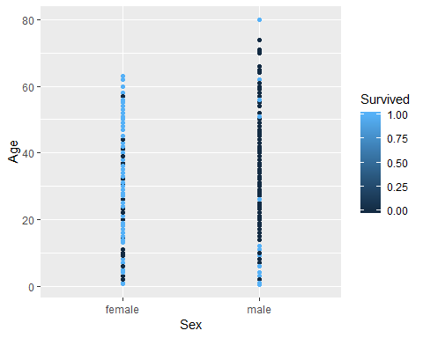

X = Sex, Y = Age

## PassengerId Survived Pclass  
## 1 1 0 3  
## 2 2 1 1  
## 3 3 1 3  
## 4 4 1 1  
## 5 5 0 3  
## 6 6 0 3  
## Name Sex Age SibSp  
## 1 Braund, Mr. Owen Harris male 22 1  
## 2 Cumings, Mrs. John Bradley (Florence Briggs Thayer) female 38 1  
## 3 Heikkinen, Miss. Laina female 26 0  
## 4 Futrelle, Mrs. Jacques Heath (Lily May Peel) female 35 1  
## 5 Allen, Mr. William Henry male 35 0  
## 6 Moran, Mr. James male NA 0  
## Parch Ticket Fare Cabin Embarked  
## 1 0 A/5 21171 7.2500 S  
## 2 0 PC 17599 71.2833 C85 C  
## 3 0 STON/O2. 3101282 7.9250 S  
## 4 0 113803 53.1000 C123 S  
## 5 0 373450 8.0500 S  
## 6 0 330877 8.4583 Q

## mapping: x = ~Age, y = ~Fare, colour = ~Sex   
## geom_point: na.rm = FALSE  
## stat_identity: na.rm = FALSE  
## position_identity

Note that the echo = FALSE parameter was added to the code chunk to prevent printing of the R code that generated the plot.

6)

ggplot(titanic) + geom_point(mapping = aes (x= Pclass , y= Age, color= Survived))

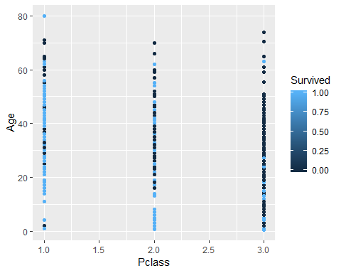

X = Pclass, Y = Age

7)

ggplot(titanic) + geom_point(mapping = aes(x= Sex, y= Age, color= Fare))

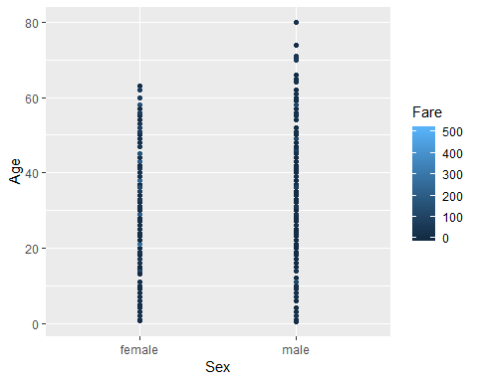

X = Sex, Y = Age